**Static library**

Installed into the executable before the program can be run

Library contains a collection of ordinary object files (each with a .o suffix → archive with a .a suffix)

Used sometimes when a provider doesn't want to supply the source code

If there are many libraries/functions this can create a very large executable file

Link to library using the -l option

Be sure to use the correct order for compilation -- file, then flag

**Shared Libraries (Also known as dynamically linked libraries)**

Loaded at program start-up and shared between programs

A large program will start and load several libraries

These will be shared automatically by any operations in the program

You can update libraries with optimal support

Override specific libraries or even functions in a library when executing a program

soname: contains directory to library→ lib(libname).so.(version number)

Real name: filename containing the library’s real code

This is the same as the soname plus a .(release number) // This is optional

Linker name: used with -L, just the soname without the version number

The libraries don't become part of the executable

The object file contains dynamic library references, assuming that the files will be there

This allows for a change to the library without a necessity for recompilation

Command “ldd” will list the dependencies of the file within the shared library

Has the extension .so

**Dynamic library**

Can be loaded and used at times other than the startup of a program

Both Static and shared can be dynamic

**Library structure**

All have src, lib, and include files

src=cpp files

include=header files, contains info for the references to the library files

lib=compiled binary files

For static the extension becomes .a

For dynamic the extension become .so (shared object)

The name of a library is lib(libraryName).so or lib(libraryName).a in the lib folder

Usr directory just means that it is local to the computer accessible to all users

System files and libraries are downloaded to the usr/lib directory

Third part/downloaded libraries should go to the usr/local/lib directory

It doesn’t appear that this computer follows these rules

An /etc/ld.so.conf file contains the directories searched for libraries

-L tells the compiler where to find the library (directory)

-l tells the compiler the name of the library

When using these, dont put a space between the -L/-l and the next argument

-l/path/to/library

When compiling and linking at the same time (not just linking to .o files), you must use the flag -Wl, -L… -Wl,-l…. These are both -W(ell)

#include will work if the file is within the same directory

If not use -I/path/to/file (dash eye) to include the file

Paths can be absolute or relative

Absolute: with reference to the root directory

Relative: with reference to the current directory

Linking two .o files creates a single executable effectively the same as a single long file

Using the <> notation searches for the library in the includes sections

Using the “” notation searches for the library in the local directory and also the includes section (dependant on the compiler)

**Hands on example**

C++ Compiling

Major steps to creating executable

Preprocessor

Takes care of preprocessor directives

Compiler

Compiler generates the .o file

Linker

Linker generates the .exe file

C++ compiles/looks at only one file at a time

Keep this in mind with definitions etc..

<https://www.youtube.com/watch?v=Wa6irrxFG88&list=PLRwVmtr-pp05Bl0j6lwXd8tU754nUEB5P&index=1>

When do you need to link to Libraries and when do you just include

<http://stackoverflow.com/questions/7096152/c-difference-between-linking-library-and-adding-include-directories>

Including a header file will replace the header reference with add definitions so that your code will run

If multiple files include the same header files

Recursive definitions can be prevented with header guards

Include files contain the declarations and prototypes of variables and functions

It contains all that a compiler will need

The linkable libraries contain the actual object code of the functions of the library

#​include "file" vs #include <file>

The difference is in the location where the preprocessor searches for the included file.

#include "filename" the preprocessor searches in the same directory as the file and any included directories containing the directive. This method is normally used to include programmer-defined header files.

#include <filename> the preprocessor searches in an implementation dependent manner, normally in search directories pre-designated by the compiler/IDE. This method is normally used to include standard library header files.

Linking to libraries:

Static:

The executable will include chunks of library code within it

In the linking step the required sections of code in the (.a) library will be added to the executable

Increases the size of the executable

Updates in the .a will require recompilation of all executables using that library

When you -I you are including everything in the executable/compilation stage

Dynamic libraries (Shared object libraries):

the executable will contain references to the library address in memory

Library is necessary in compile and runtime

No problem of size, updates easier

(.so)

All C++ STL (standard libraries) are .so format

Static:

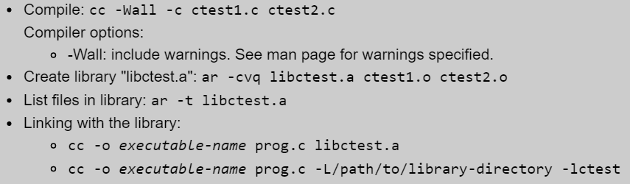

Link by including the library name in the compilation or using the -L -l format

Shared object libraries only use the -L -l format

If you wish to do compiling and linking at the same time, use the -WL, -Wl flags instead

Shared Object Library:

With a shared object library there is often a symbolic link in the filesystem to the library

This is done so that you can use the syntax -L PATH -l name and disregard the version numbers specified at the end of the soname. That way if the library is updated, the symbolic links can stay in tack



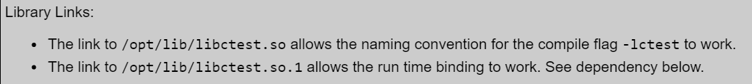

See what other libraries a library depends on with the ldd commna

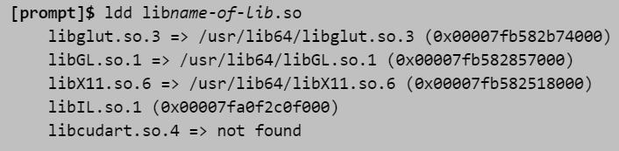

Produces error...

Fix:

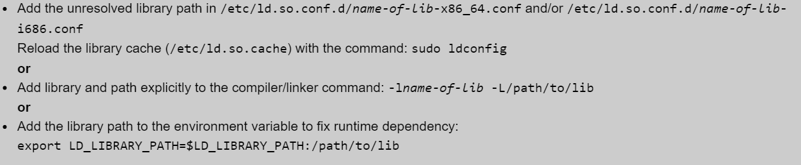

**The /etc/ld.so.conf file**

This file will have a list of directories to be searched for shared libraries

With ldconfig this is run and all symbols and specifies all dynamic link libraries etc.

This is then stored in /etc/ld.so.cache

This may mean that if a new library is downloaded you may need to run ldconfig

**LD_LIBRARY_PATH**

Is a smaller set of paths which is an environmental variable

Order of library search:

-L, -l

LD_LIBRARY_PATH

/etc/ld.so.conf file (from the cache, refreshed with ldconfig)

**Makefiles**

Variables (macros) are defined at the top

Just using the “CC=g++” style

CC is used to denote the compiler

CFLAGS is used to denote flags for the code

LFLAGS is used to denote library flags

DEBUG used for debugging ex. -g

DEPS is used to define the dependencies for a file ex. the header file for a .cpp

% is used as a wildcard ex. “%.o” refers to all object files

-@ is the name of the file being generated

-o $@ (allows for easy renaming of the output file)

$< refers to the first file to the right of the output file

Ex. hello.o: hello.c hello.h

Gcc -c $< -o $@

$< is replaced by hello.c

$^ is replaced by all files to the right of the output file

hello.c, hello.h

**Cmake**

Cmake list creates a makefile

CMakeLists.txt --- contains makefile instructions

To run:

cmake .

(in the current directory)

**Shell scripting**

Just executes the commands listed so that you don’t have to do them repeatedly

Pipe output to a file (both cout and cerr)

./runtests.sh 2>&1 | tee output.txt

**Path variable**

The ~/.bashrc file is executed upon each new instance of the terminal

In it the $PATH variable can be altered

This variable is used to define directories searched when a command is entered to the command line. The binary files must be specified

**Further Reading**

<http://tldp.org/HOWTO/Program-Library-HOWTO/index.html>